Creating folders and pages in Dreamweaver
To complete this you should know:
- How to use the Site Manager
- How to open an existing site
You will learn:
- How to create folders and empty pages the Dreamweaver way.
- How to rename and move files in the Site browser.
- How to create a layout table and switch layout views on and off.

Part 1: Preparing your site
I never use the File menu in Dreamweaver to create, save as or save pages. The site browser window is a much more useful and convenient tool.
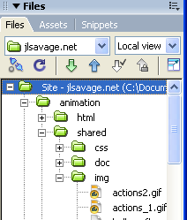
To create folders and pages in Dreamweaver
- Make sure you have loaded your site file: Manage sites -> Import
- To create a new project folder, right click on the top-level folder (called Site – My I drive on yours) and choose New folder. Name the folder remembering the naming conventions (only numerals, the letters a-z, “-“ and “_” instead of spaces).
- Right click your project folder and create a folder for your pictures and artwork. Save the pictures you will need into this folder. . It is very important that you have prepared your images and have a table of your pictures that lists their dimensions in pixels. Use Photoshop or Fireworks to help you.
- Right click in your project folder (not your pictures folder) and choose New file. Give your new file a name and make sure it has the extension .html

Choosing the right view
You will see this toolbar at the top of pages in Dreamweaver. Use it to give your pages titles and to choose how you want to work with your page – raw code, WYSIWYG (What You See Is What You Get) or both. Choose Design if you are a beginner.
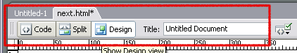

Part 2: Basic page editing
Dreamweaver lets you design layouts for your pages before you have placed any content in them. You should have sketched your pages and prepared artwork and photographs before proceeding any further
- Double click on a page in the site browser to start editing it.
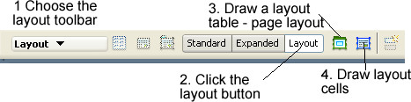
- Click on the toolbar near the top of the main window and choose the Layout bar then click on Layout and click OK.
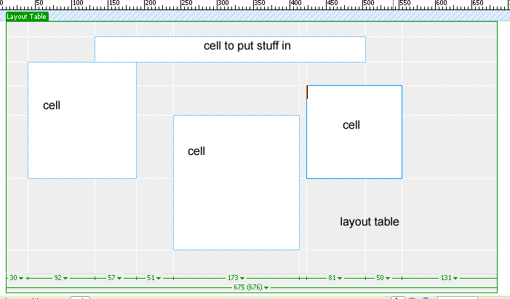
- Draw a layout table and cells on your page to match the plan you have for your web page. The properties bar lets you adjust the widths and heights accurately.
- You can type in the layout cells or drag pictures from your pictures folder.
- To open and close the layout view click the Standard or Layout buttons in the Layout tool bar.

Making Links
Making links is child’s play.
- Select the text or picture that you will use for a hyperlink.
- To link to another file in your site press the Shift key while you drag from your selected text to a file in your Site browser. It takes practice.
- To link to an external site like Google:
  - Open the site in your web browser (Firefox, IExplorer etc) and copy the URL from the address bar.
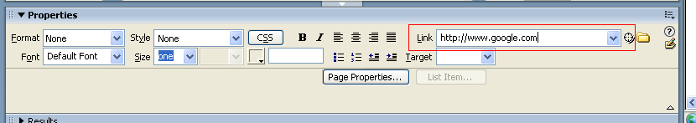
  - Paste the link into the link field in the properties bar

Styling your page
If you click the Page properties button on the Properties bar this form will appear. Play with it. (If the Page properties button does not show you can get there by choosing Modify -> page properties from the menu bar)
Play with the tags I’ve highlighted
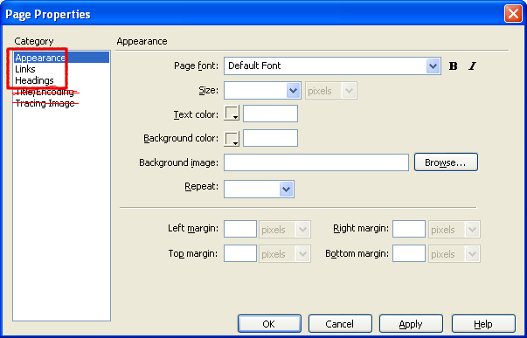

Moving and renaming files
This is very important
If you need to rename or move a file (picture, web page etc) you must do it through the site browser window. You can drag and drop files and rename them by right clicking and selecting from the EDIT sub menu. You will be asked if you want to update your links. Always answer yes.

